- The UK grew at an above-trend pace in H1 2024, but we don't expect this to be sustained over the next couple of years. However, we are more optimistic than the consensus. Our forecast that GDP will grow by 1.7% next year is based on the notion that consumers will finally shed their caution and make a stronger contribution to growth.
- The likelihood that fiscal policy will be tightened in the Budget on October 30 is a key reason why we expect growth to slow. Our forecast assumes the Chancellor will implement an extra £10bn (0.4% of GDP) worth of tax increases from next year, on top of the measures set out in Labour's election manifesto. But a larger tightening is possible, particularly if the Chancellor decides not to tweak the fiscal rules to remove the impact of Asset Purchase Facility losses.
- We're now in the early stages of an interest rate cutting cycle, with the Bank of England's messaging consistent with 25bps rate cuts at every other meeting. While companies should benefit from rate cuts fairly quickly, for the household sector the lagged impact of past rate hikes will continue to dominate over the next eighteen months.
After two years of stagnation, the UK economy enjoyed a strong recovery in H1 2024, with quarter-on-quarter GDP growth of 0.7% in Q1 and 0.6% in Q2. What's more, the pickup was despite a relatively weak contribution from consumer spending – though it accounts for just over 60% of the economy, household consumption accounted for less than one-third of the increase in GDP in H1 2024.
On the plus side, we're optimistic that consumer spending will play a stronger role in the recovery moving forwards. But on the flip side, we think other categories will offer smaller contributions to growth. Stockbuilding has provided a sizeable boost but that should now wane, while recent fiscal policy changes will restrain real government consumption. With the lagged impact of past interest rate hikes also continuing to emerge, we think the economy is unlikely to sustain the well-above-trend pace seen in H1 2024. However, we think the consensus forecast – which implies that average quarterly growth across H2 2024 and 2025 will be roughly half the pace seen in H1 2024 – is too gloomy (Chart 1).
Chart 1: We expect GDP growth to slow, but not by as much as the consensus
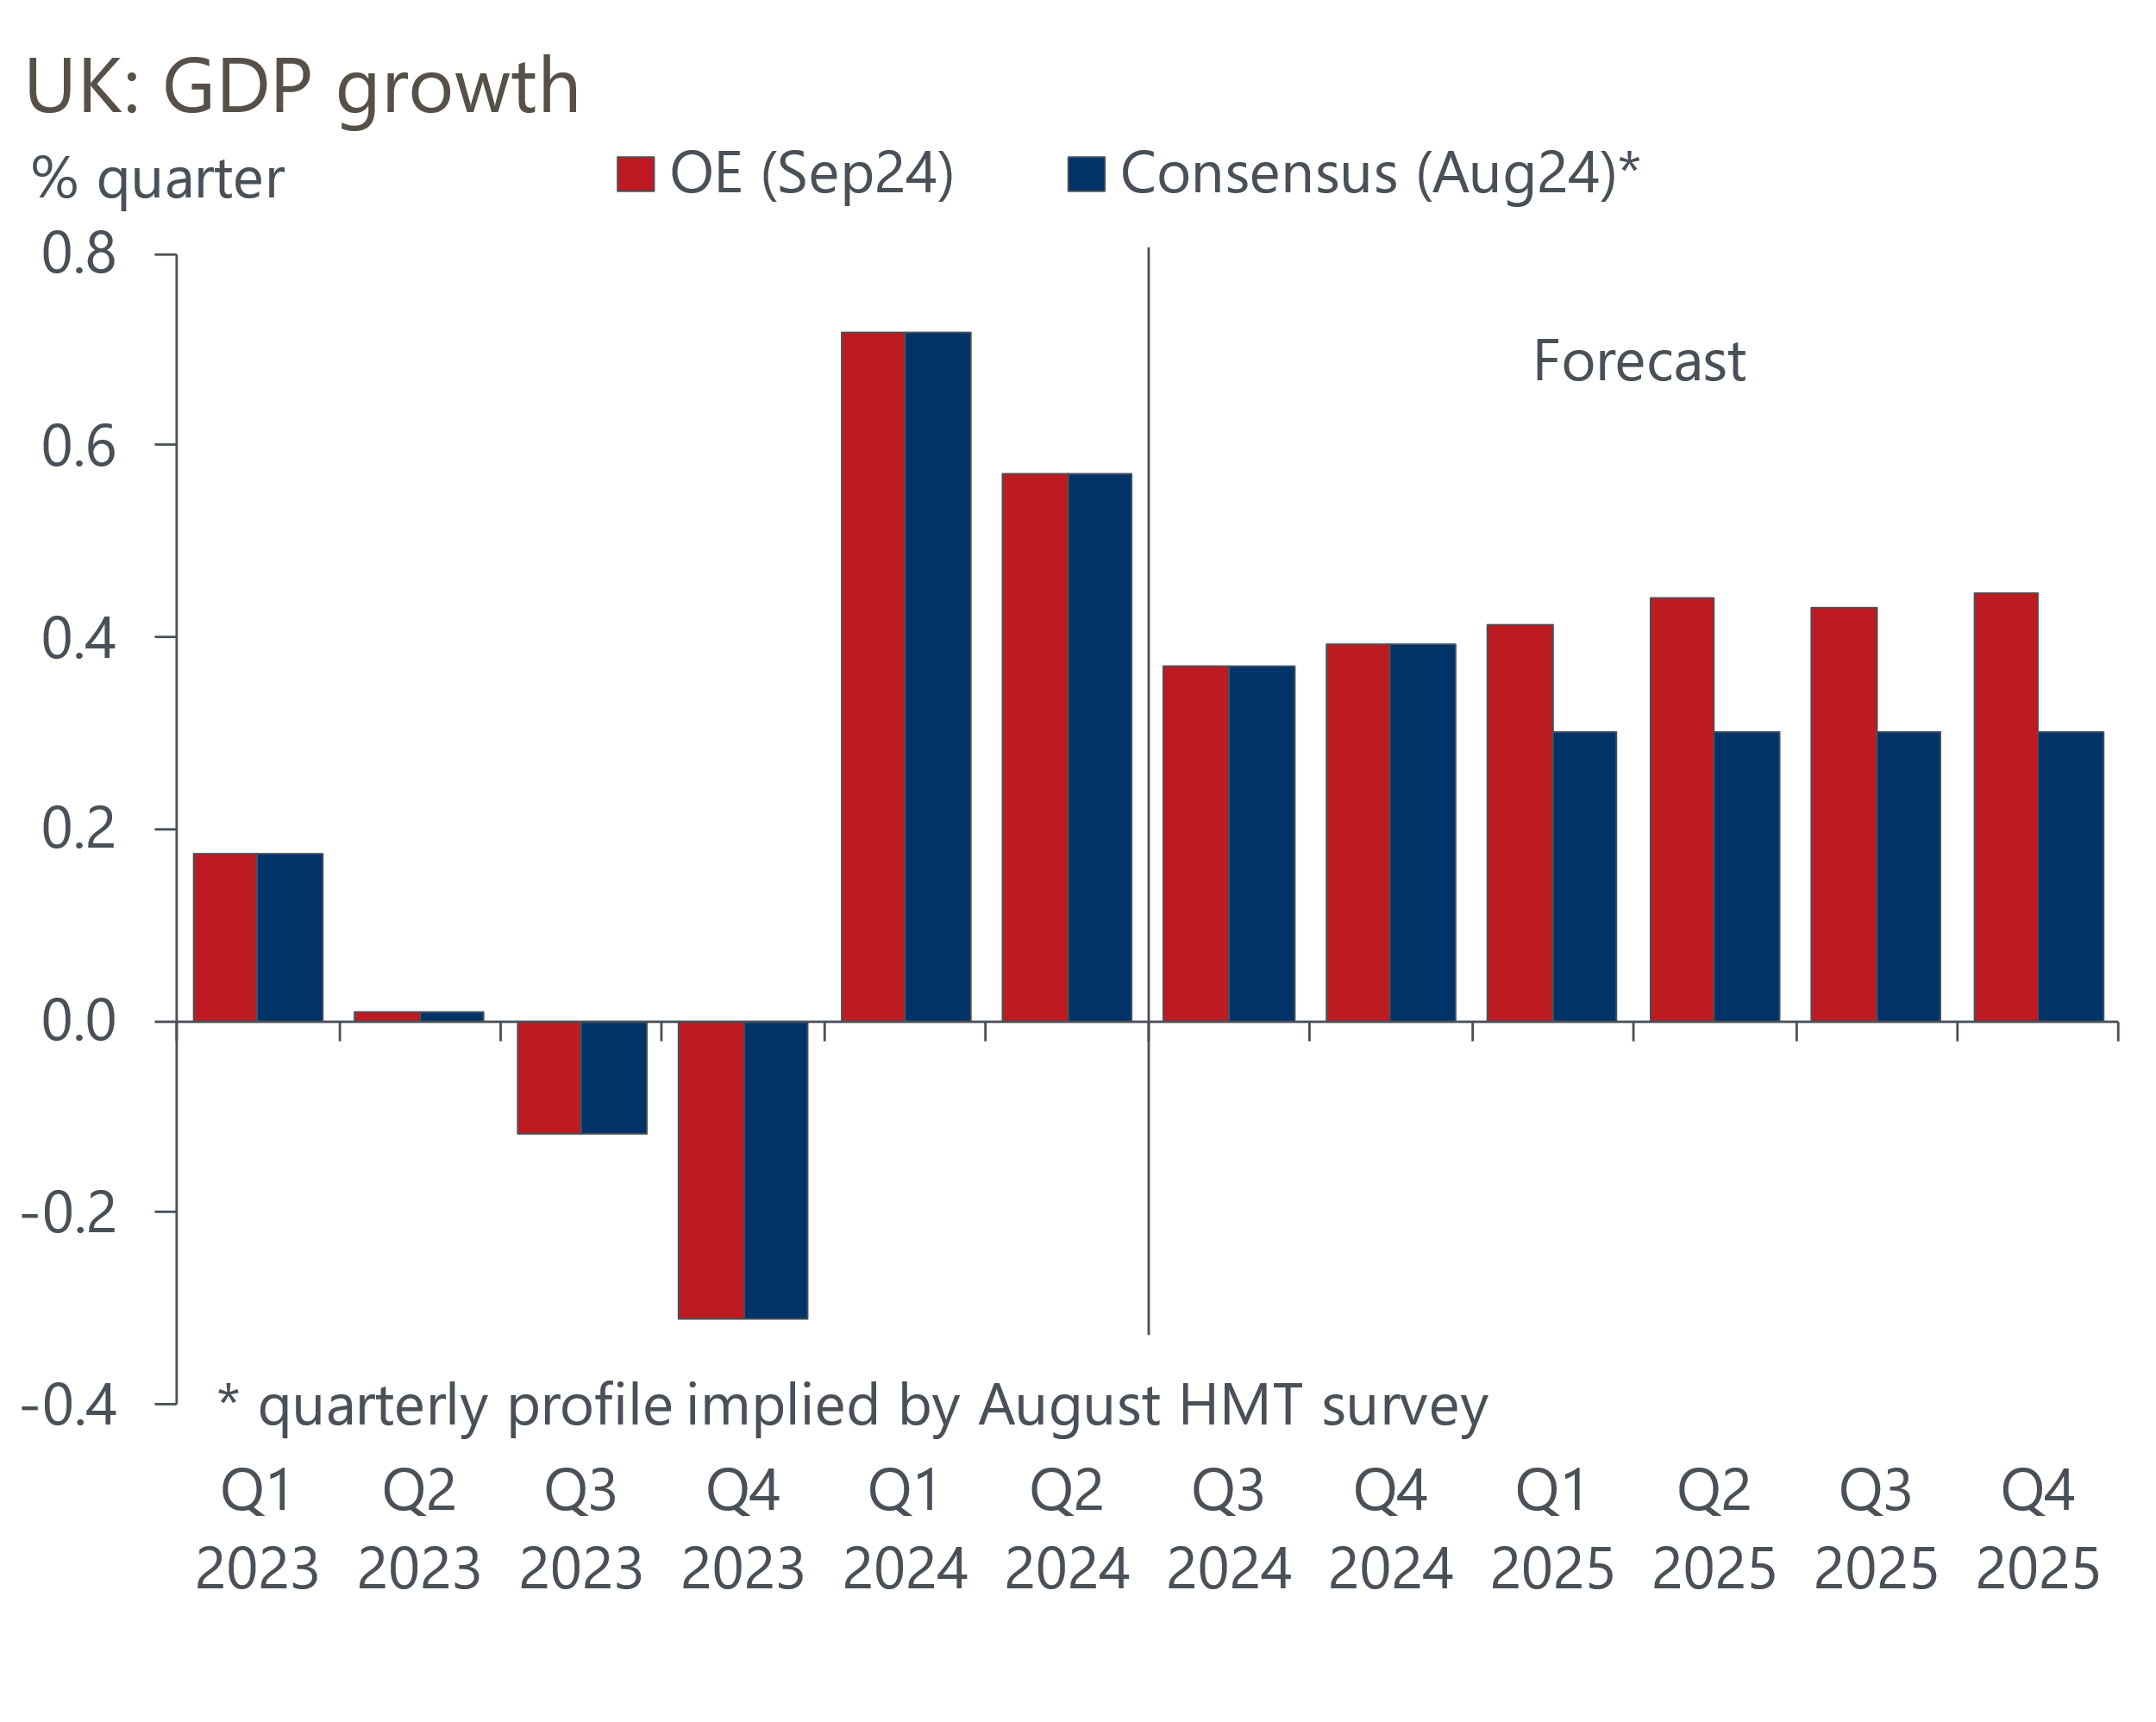
Sources: Oxford Economics, Haver Analytics, HM Treasury

Though inflation has troughed, wages will continue to grow in real terms
Our optimism on consumer prospects is based on the expectation that real incomes will continue to grow at a solid pace, and that consumers will shed the very cautious behaviour they have shown over the past year. The recovery in spending power has been strong – in the year to Q1 2024, real household disposable income grew by 3.1%, driven by a combination of much lower inflation, strong wage growth, and last year's bumper inflation uprating of social benefits.
Inflation will not likely drop further. Falling energy prices were the key driver of the decline over the past year, dragging on CPI inflation by more than 1ppt in Q2 2024. But the drag has already started to fade, with July's fall in the energy price cap being less than half of the drop a year earlier. The EPC will increase by 10% in October, and by next spring the drag from the energy category is likely to have disappeared. We expect the impact to be mitigated by firms passing on their lower energy costs to consumers, and by cooling services inflation. But these factors are unlikely to prevent inflation temporarily rising above 2.5% around the turn of the year (Chart 2).
Chart 2: Inflation will rise around the turn of the year as the drag from falling energy prices fades
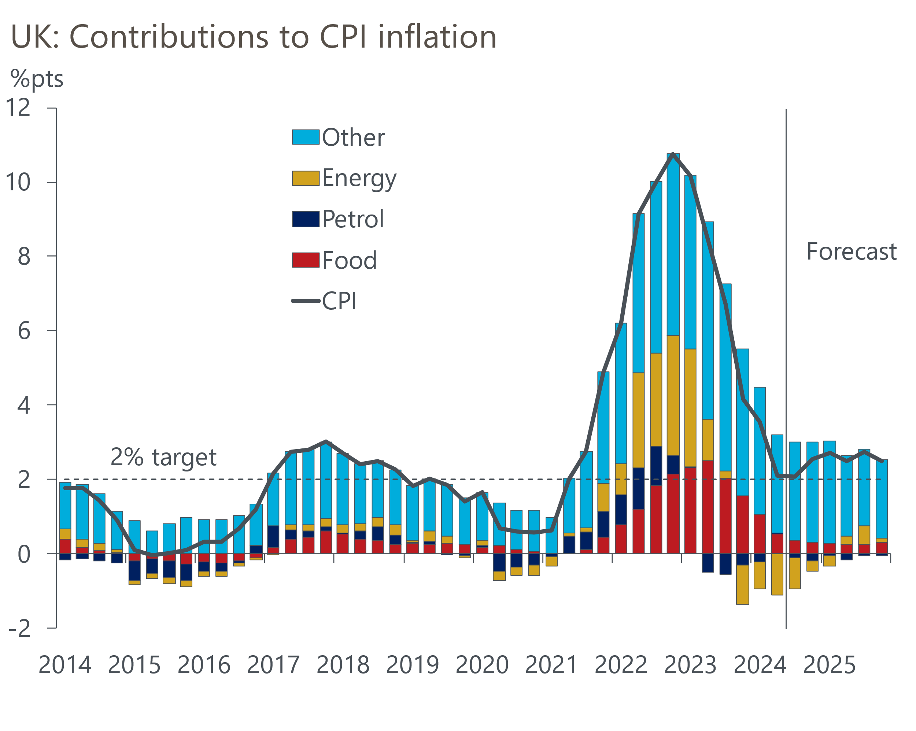
Sources: Oxford Economics, Haver Analytics
Still, we expect pay growth to remain well above inflation. This is partly because the government has accepted the recommendations of pay review bodies and given pay rises of 5%-6% to many public sector workers.
We think the risk of spillovers from higher public sector settlements to the private sector is limited, but the slowdown in private sector pay growth is likely to be gradual. Labour market conditions are consistent with the output gap being close to zero, and labour demand should increase in response to stronger economic growth. The lagging nature of the wage setting process and enduring pressure to mitigate the hit to real wage levels seen since the start of the pandemic will also ensure the slowdown in pay growth is gradual.
So while real wage growth is unlikely to be quite as strong as it has been of late, we still expect it grow at a solid pace over the coming year, supporting household spending power (Chart 3).
Chart 3: Sustained real wage growth will support consumer spending power
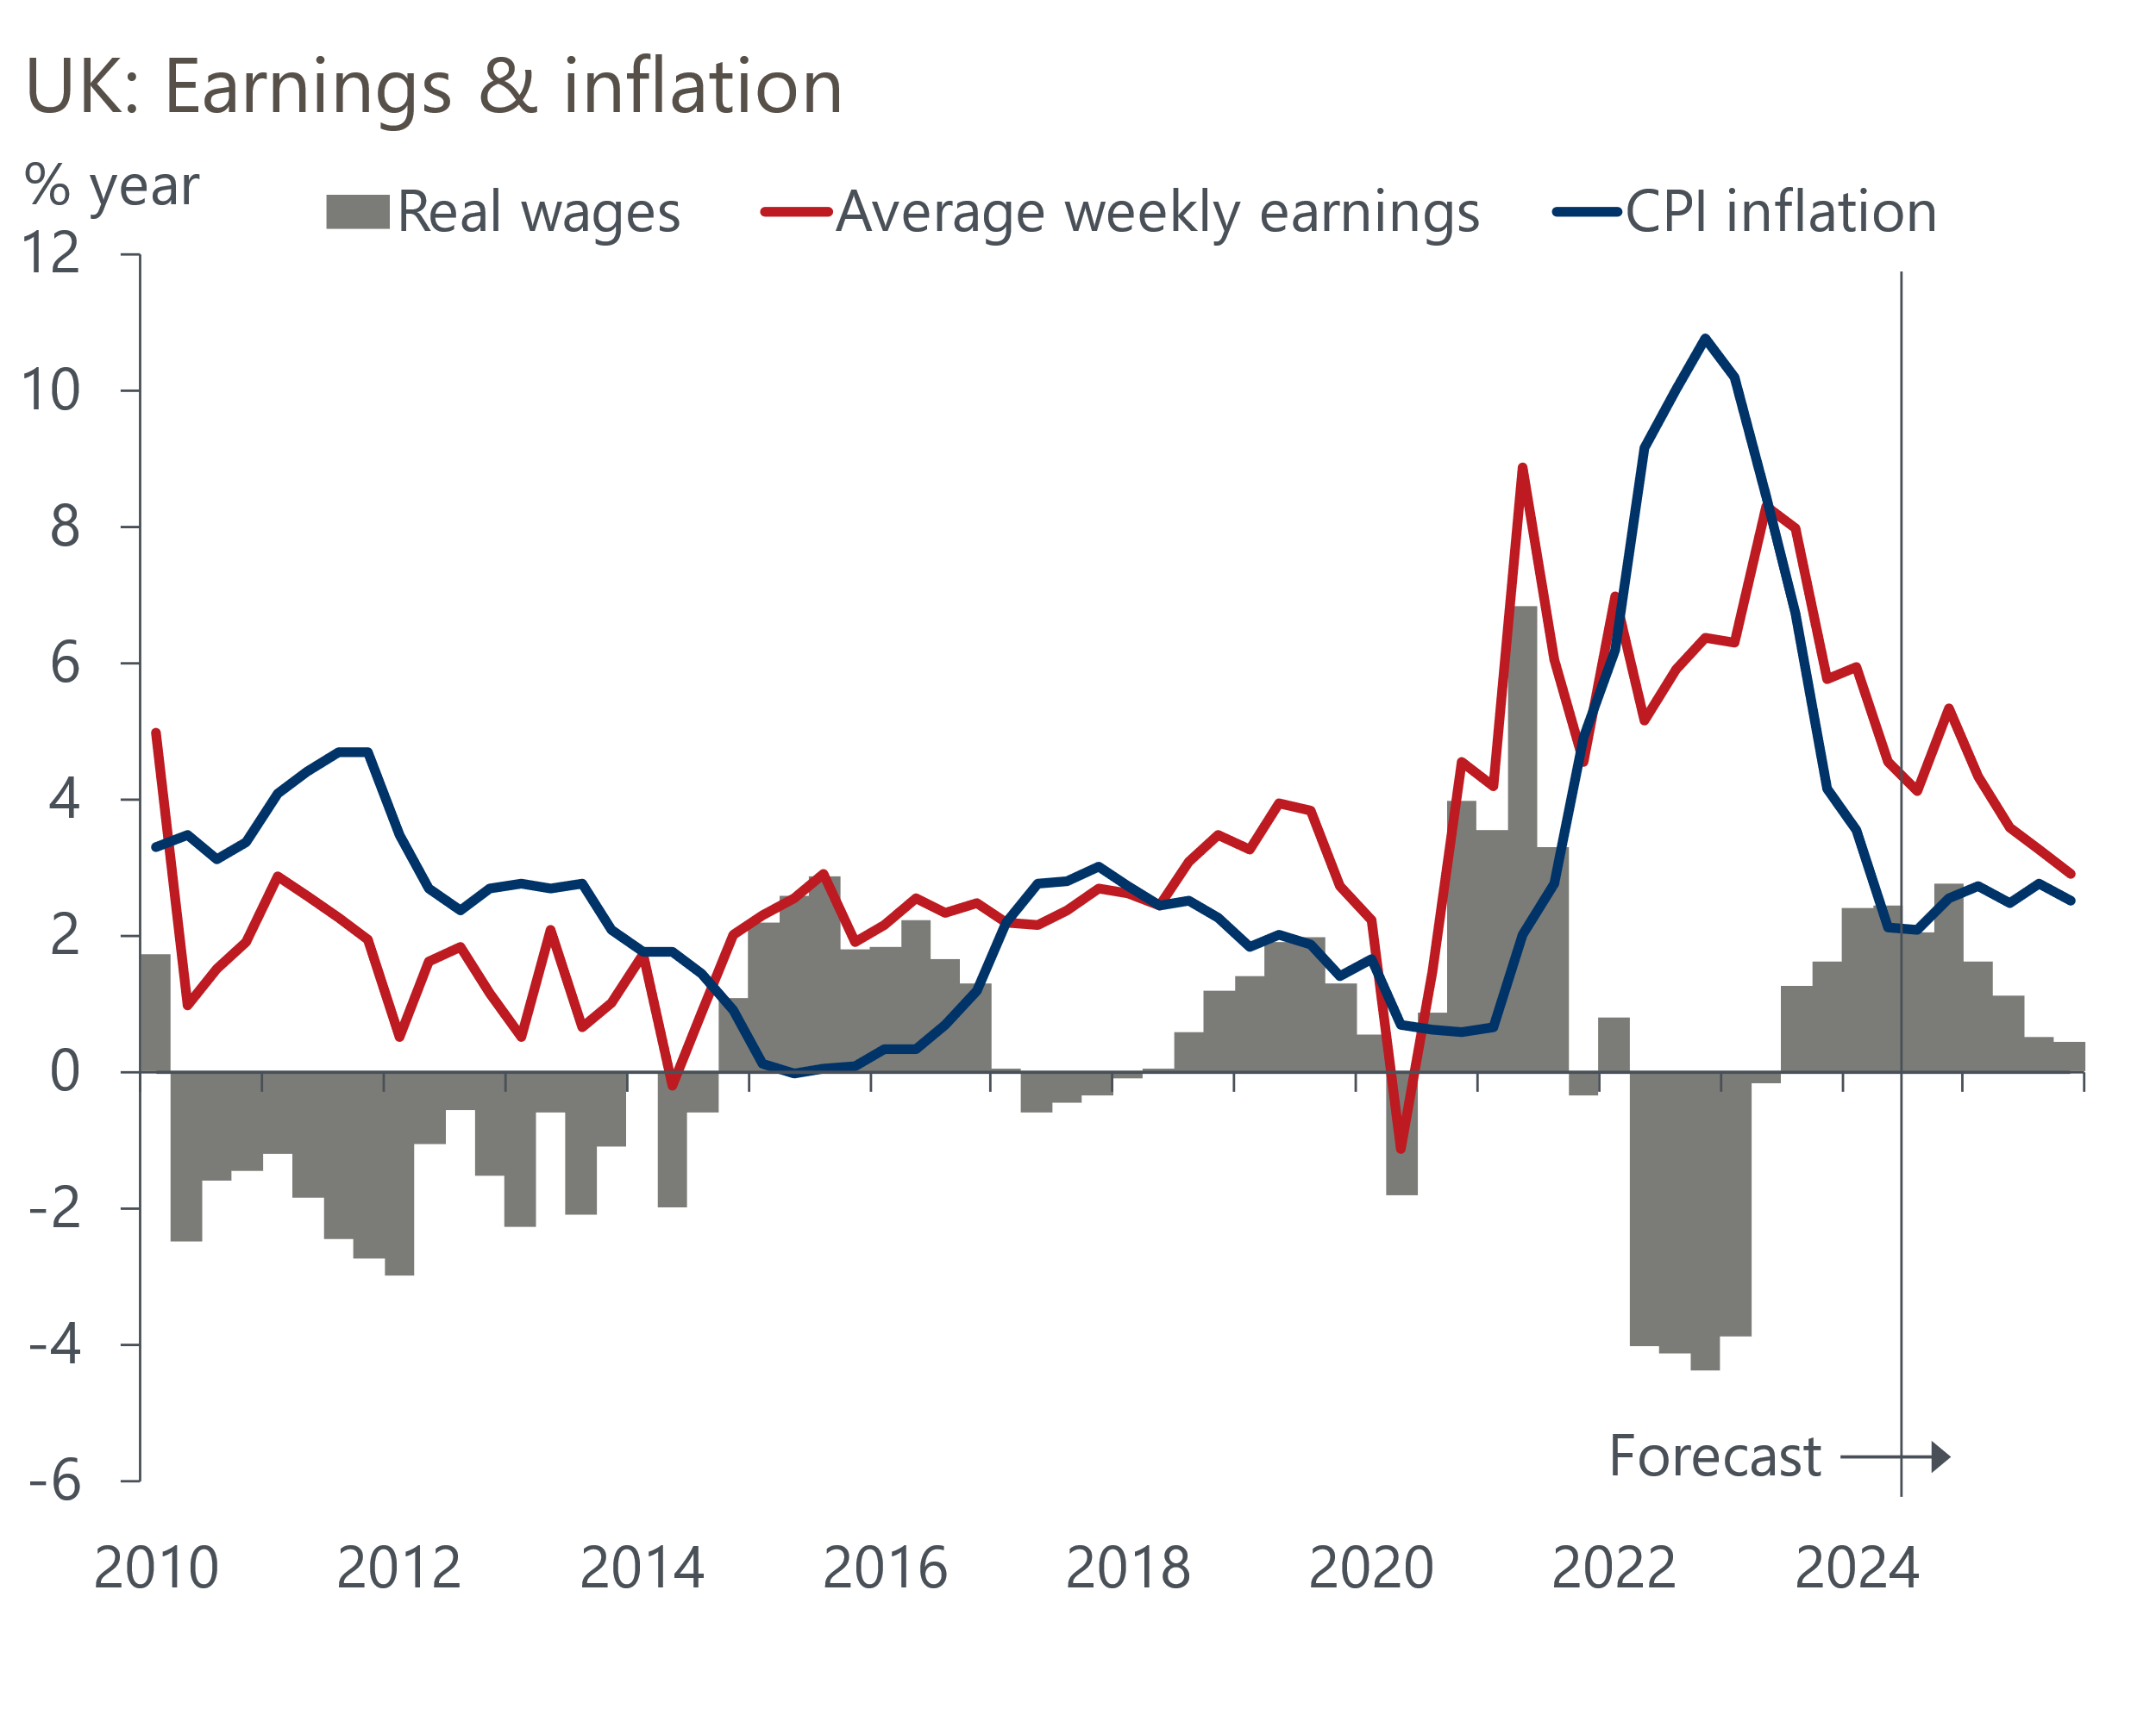
Sources: Oxford Economics, Haver Analytics
Other forms of income are also growing strongly because of the link to past inflation rates – in April, most social benefits were uprated by nearly 7%, while the state pension increased by 8.5%. With workers also benefitting from the 4ppts cut to the rate of national insurance contributions made in H1 2024, real household income growth should remain strong in H2 2024. These factors will fade next year, while the impact of the ongoing freeze in most tax allowances and thresholds will continue to weigh. But we still expect real incomes to grow by more than 1% in 2025.

Less cautious behaviour is central to an improving consumer outlook
The key uncertainty around the consumer outlook is the extent to which solid real income growth translates into higher spending. Though real incomes grew by 3.1% in the year to Q1, spending fell by 0.2% over the same period. Furthermore, in Q1 the household saving ratio of 11.3% was 3.5ppts above the average seen in the decade prior to the pandemic.
But survey data suggest the consumer mood is changing. GfK's headline measure of consumer confidence is now back above its average for the past ten years, as are respondents' expectations about their financial situation (Chart 4). And though their desire to make major purchases is slightly weaker than its long-run average, this balance is also rapidly moving in the right direction.
Chart 4: Consumers are becoming more confident about spending
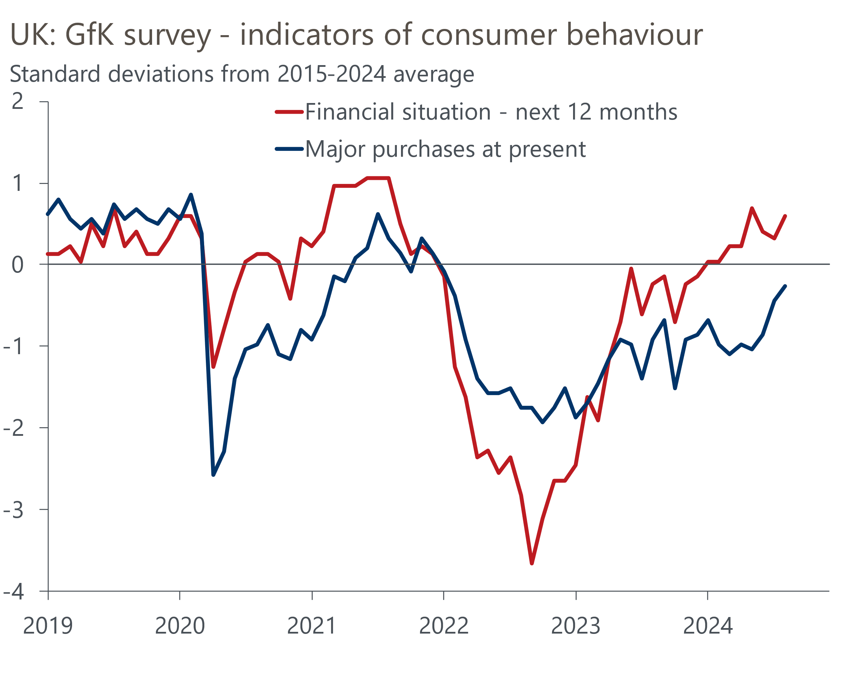
Source: Oxford Economics calculations using data from Haver Analytics
Further solid income growth and falling interest rates should mean this trend continues. So we expect consumer spending growth to run ahead of increases in real income over the next couple of years.

Fiscal policy will be a key influence on growth over the next few years
Though our forecast is above consensus, it shows calendar year GDP growth of just 1.7% next year, relatively low by historical standards. That growth is unlikely to exceed 2% reflects the scale of the drags from tight fiscal and monetary settings and low potential output growth.
Fiscal policy is in a state of flux until new Chancellor Rachel Reeves presents her first Budget on October 30. She inherited plans from the previous government to tighten policy by more than 3% of GDP over the course of the five-year parliament via both higher taxation (largely through an extended freeze in tax allowances and thresholds) and significant spending restraint. Labour's election manifesto was largely silent on this inheritance and presented a package of small-scale, fiscally neutral measures that will have little impact on the outlook.
But the Treasury's audit of departmental spending plans, published at the end of July, offered a stronger indication of the likely direction of travel. The audit found that departmental spending is on track to overshoot the previous government's plans by £22bn (0.8% of GDP) in fiscal year 2024-2025, more than half of which was due to higher public sector pay awards than had been budgeted for. But the audit didn't include the sizeable spending pressures the government will face in future years. The challenge of converting spending totals into department-by-department plans, and the likelihood that a large chunk of this year's overspend will recur, mean we think the government will ultimately increase the size of the spending envelope.
This means that tax increases look likely, but their size and timing are uncertain. It will partly depend on how much the government decides it needs to increase spending to deliver its planned improvements in public services. The addition of an extra year to the Office for Budget Responsibility's forecast horizon will provide some extra wiggle room, but that might only match the recurring element of this year's overspend.
Another way of creating extra headroom would be to tweak the debt rule to exclude losses made by the Asset Purchase Facility. This could free up around £20bn (0.7% of GDP) of fiscal space and would be a sensible move. These losses are outside of the government's control, while the costs will cease as soon as the Bank of England finishes selling gilts, which the OBR currently assumes will happen in 2032-2033. So the current system is effectively imposing an artificial constraint for the next couple of years, which will then disappear in the second half of the parliament – this is a poor basis for setting policy.
We think the Chancellor will make this tweak, but that she will still need to impose £10bn (0.4% of GDP) worth of tax increases beyond those set out in Labour's manifesto to comply with the fiscal rules and provide an acceptable amount of headroom. We assume these tax rises will be implemented by the start of the next fiscal year in April, and that the Chancellor will stick to Labour's pre-election commitment not to increase national insurance, the basic, higher, or additional rates of income tax, and VAT.
However, if Reeves does not tweak the debt rule, then the tax increases will likely be larger, and the government will find it harder to keep its manifesto commitment. In this scenario, the obvious move would be to reverse the cuts to national insurance contributions that the previous government implemented in H1 2024. This could be justified on the basis that the cuts were only possible because the government made implausible assumptions about future spending restraint, and that moving to more realistic spending assumptions had shown that the tax cuts were unaffordable.
The upshot of our assumptions is a substantial tightening of policy, which is fairly evenly spread over the course of the parliament (Chart 5). Both tax revenues and government spending will be higher as a share of GDP than they would have been under the previous government's plans.
Chart 5: Fiscal policy will be tightened significantly, but the timing and composition are uncertain
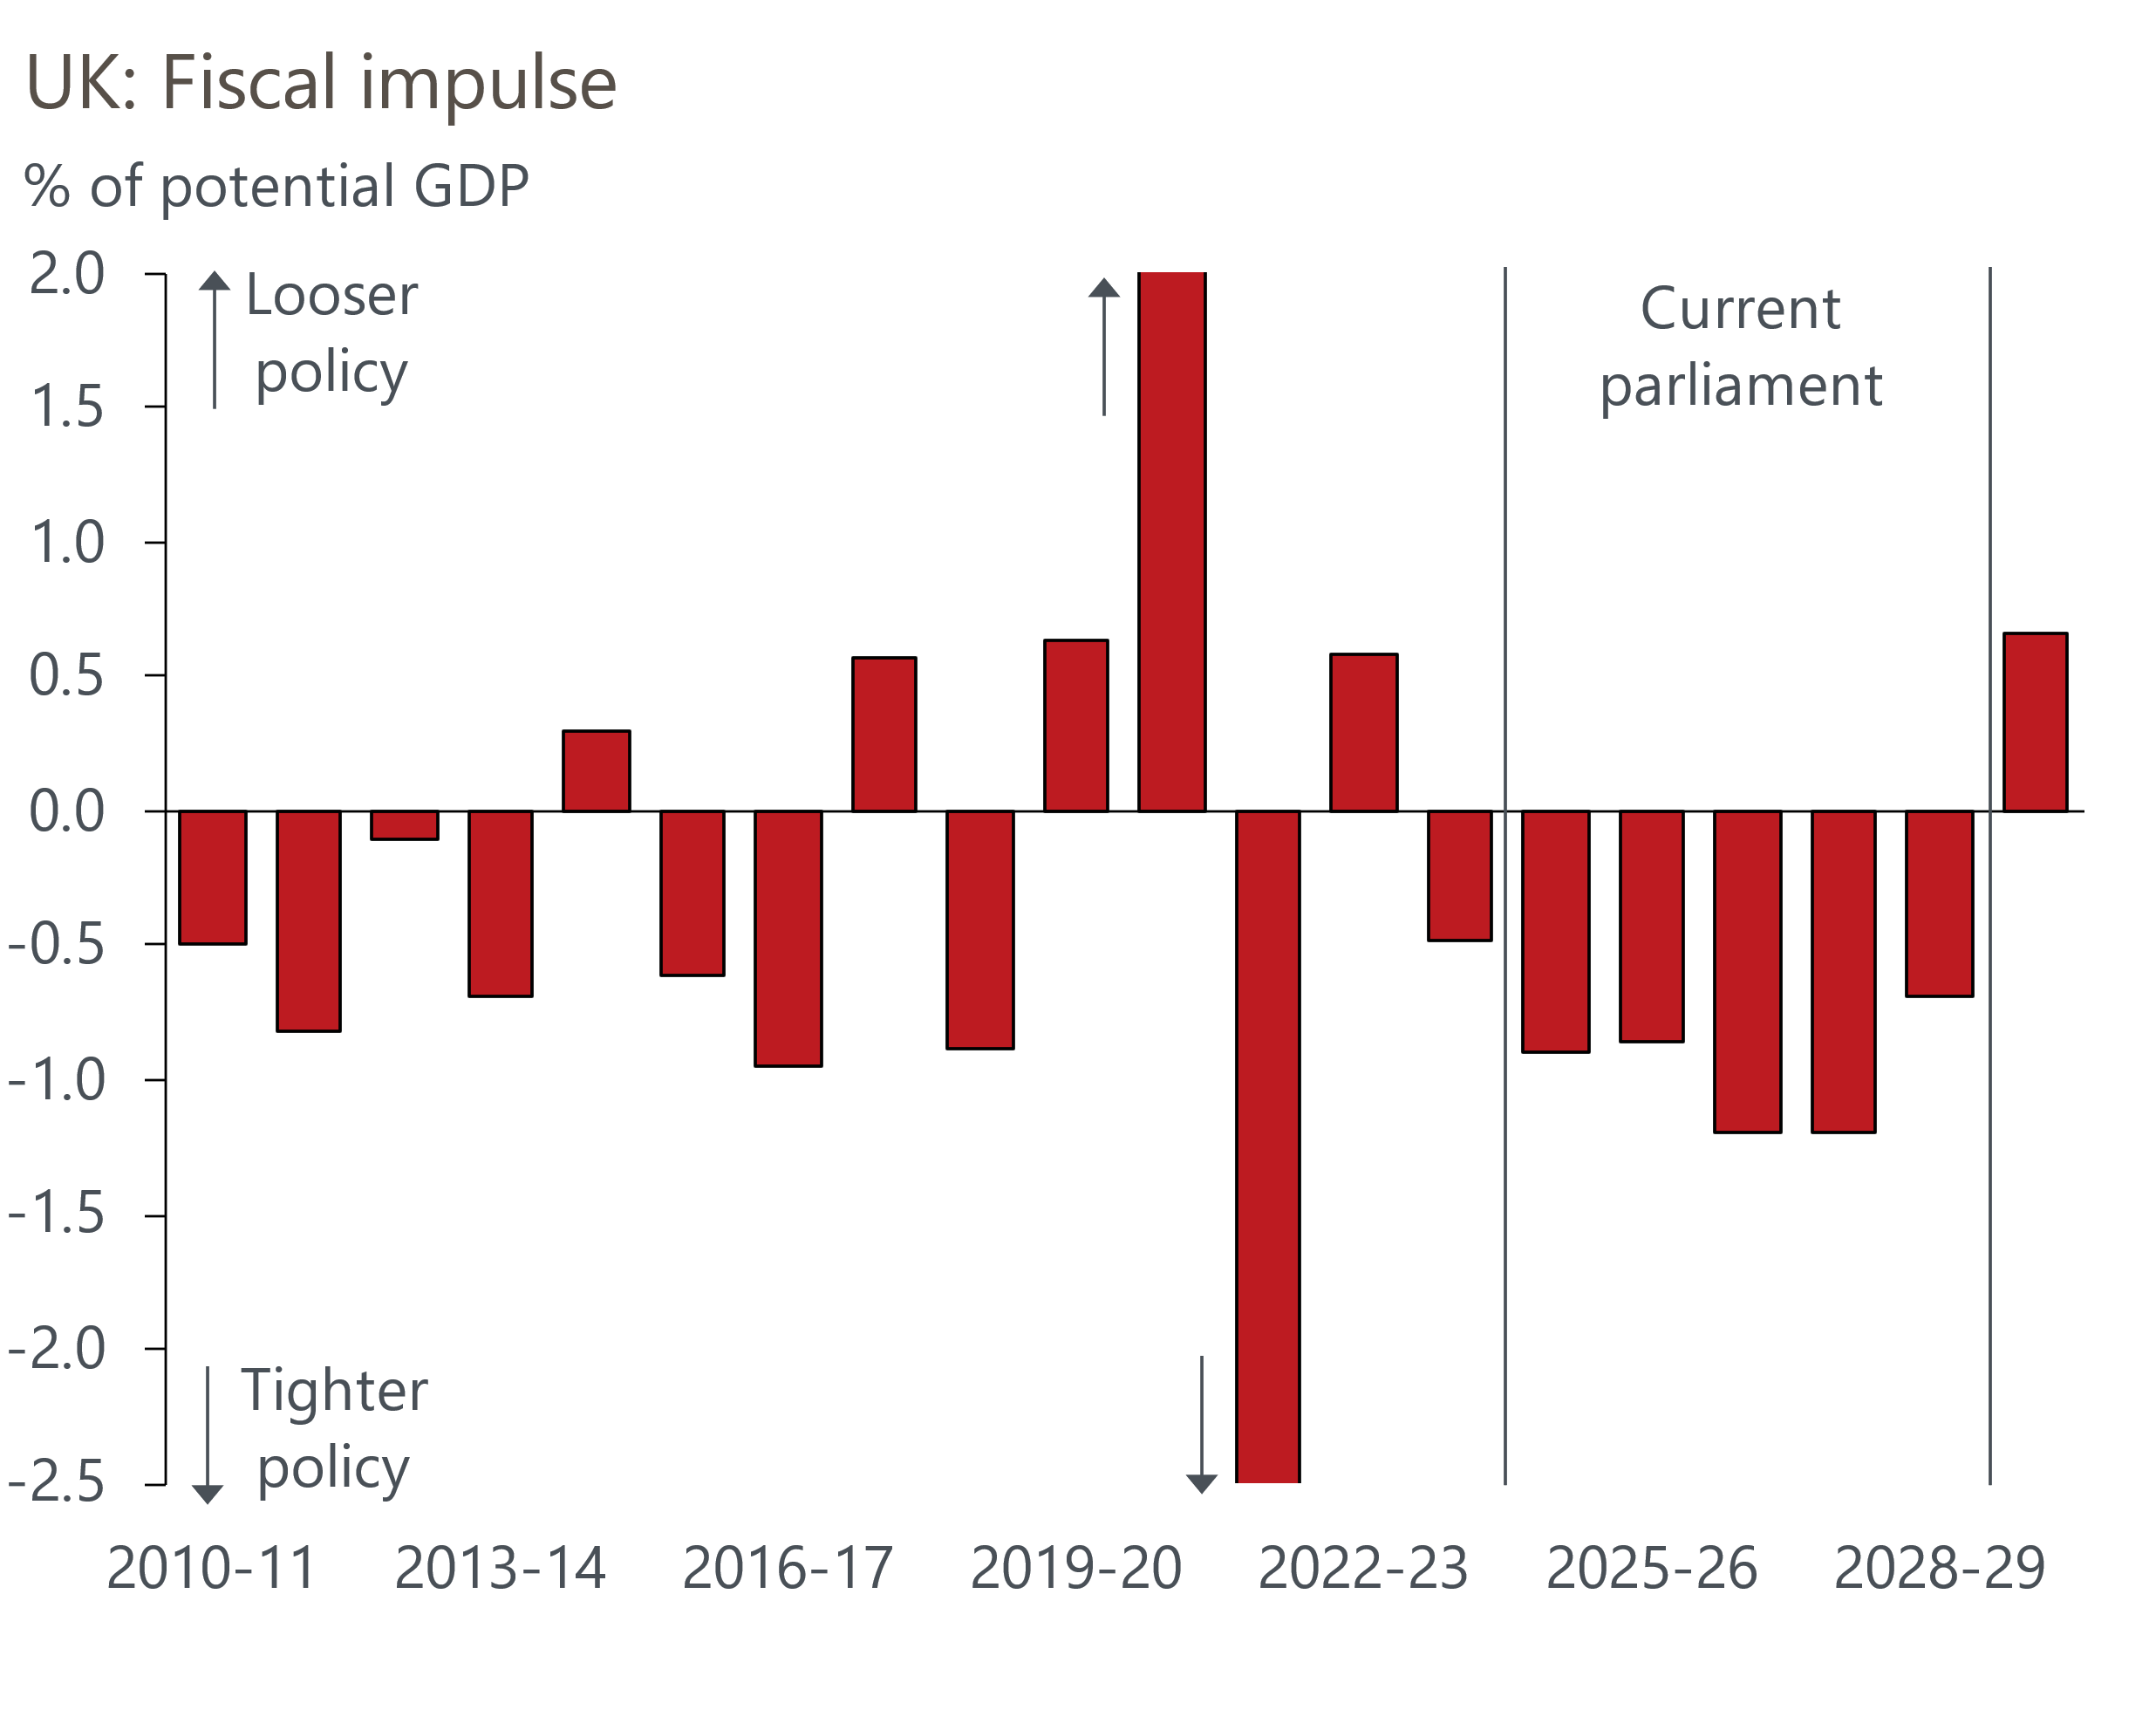
Sources: Oxford Economics, Haver Analytics
But there's huge uncertainty over the timing of the consolidation and the tax/spending mix. We think a plausible alternative scenario would see the government front-load the tightening – this would get the bad news out of the way early while it has plenty of political capital and allow time to rebuild before the next election. Another plausible alternative is that the government repeats the mistakes of previous administrations, most notably the 2010-2015 coalition, and cuts capital spending. The recent decision to cancel several transport projects suggests the government might find this option attractive, but it would jar with its pro-growth rhetoric and plans for investment in green energy.

Steady loosening of monetary policy is in prospect, but the impact of previous hikes will dominate
The choices the government makes on fiscal policy may influence the Bank of England's monetary policy decisions. But our baseline forecast assumes the Monetary Policy Committee follows the gradualist approach to rate cuts that they advocated at August's meeting. Our interpretation of the MPC's message is that they expect to cut by 25bps every other meeting. This would leave Bank Rate at 4.75% at the end of this year, and 3.75% at the end of 2025. Financial market pricing implies a slightly faster pace of cuts over the next six months, but that Bank Rate will end next year in a similar place to our forecast (Chart 6).
Chart 6: We think the MPC will move more slowly than markets anticipate, but end up in a similar place
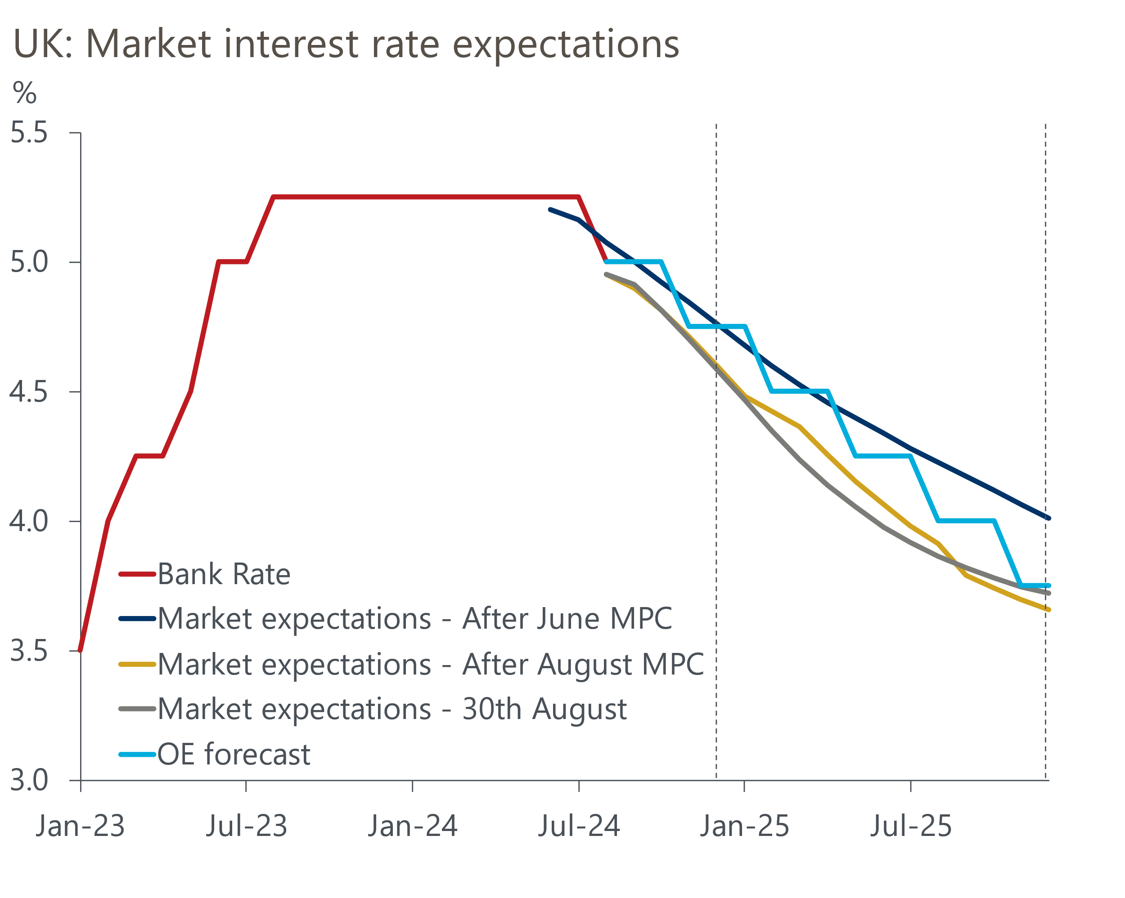
Sources: Oxford Economics, Haver Analytics
Given the MPC's clear messaging, a quicker pace of rate cuts would require strong evidence that inflationary pressures are softening faster than anticipated. But we think inflation and pay growth will prove too sticky to justify such a switch. Indeed, we view the risks to our BoE call as broadly balanced.
More aggressive tightening of fiscal policy might trigger faster rate cuts, though this would require the MPC to adopt a more balanced consideration of growth and inflation dynamics than they have in recent years. Their recent shift of emphasis away from data dependence to a more forward-looking approach to inflation demonstrates that the MPC is prepared to adjust its focus. But given that the inflation battle has not yet been decisively won, it's far from certain that the MPC would be ready to place a greater emphasis on growth in the next six months.
The experience of the rate hiking cycle suggests the passthrough of rate cuts to corporate interest rates will be quick (Chart 7). Alongside a more stable political backdrop, this underpins a solid outlook for business investment.
Chart 7: Corporate interest rates were much more responsive to Bank Rate hikes than household rates
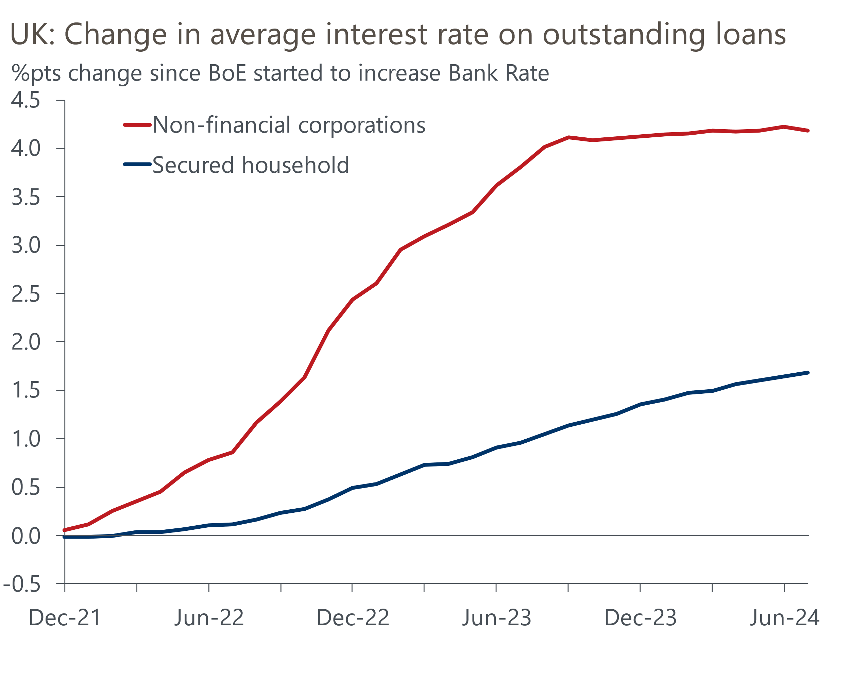
Source: Haver Analytics
But the transmission to household interest rates will be more protracted. This is because many borrowers are yet to refinance cheap fixed-rate deals that were taken out before mid-2022. For those homeowners refinancing expiring five-year fixed-rate mortgages before the end of 2025, we calculate that the increase in interest rates is likely to be around 250bps if they take out an equivalent fix (Chart 8).
Chart 8: Though we expect Bank Rate to be cut, many households will see their interest payments rise
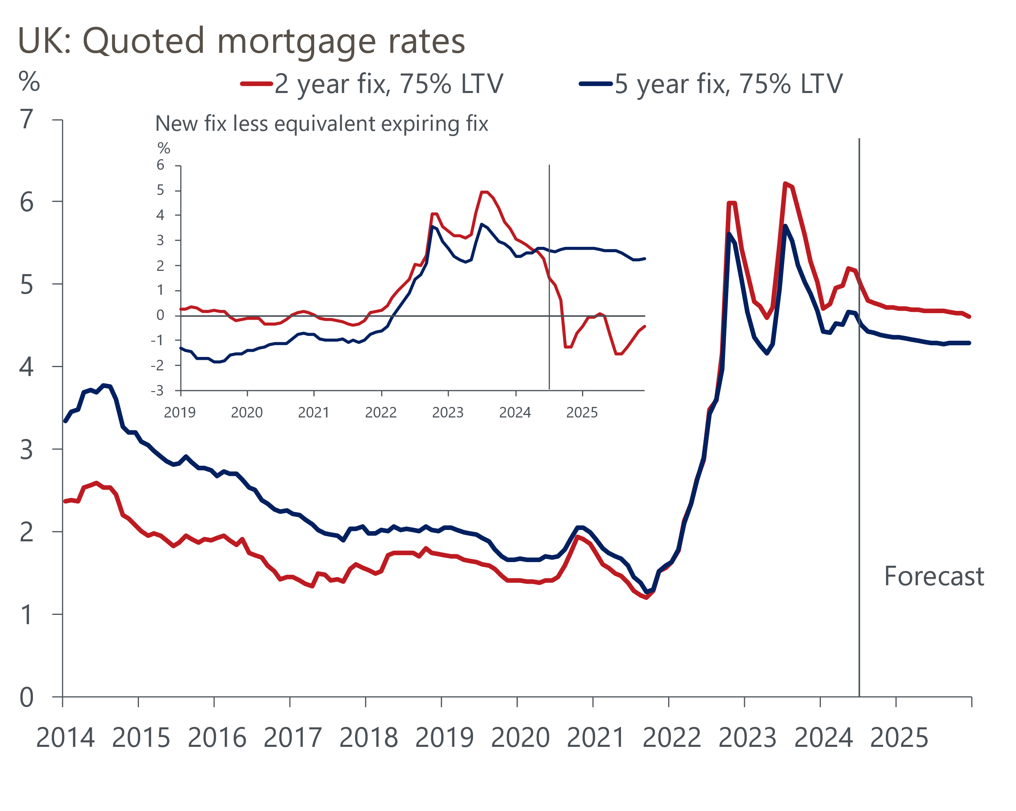
Sources: Haver Analytics, Oxford Economics
This will more than offset the impact of cheaper variable-rate mortgages and ensure that aggregate household interest payments will continue to rise. Alongside tighter fiscal policy, the lagged impact of past monetary tightening will keep a lid on economic growth.

